**PERMISSION SETS**

**Permission Sets**

|  |  |
| --- | --- |
| **Team id** | AD47707C5D4D5109D5E480002BDB30D5 |
| **Project Tittle** | Build an Event Management System using salesforce |

**From setup search “permission sets” in quick find and select permission set then click on New >> Enter label as: Vendor Permits and Save.**

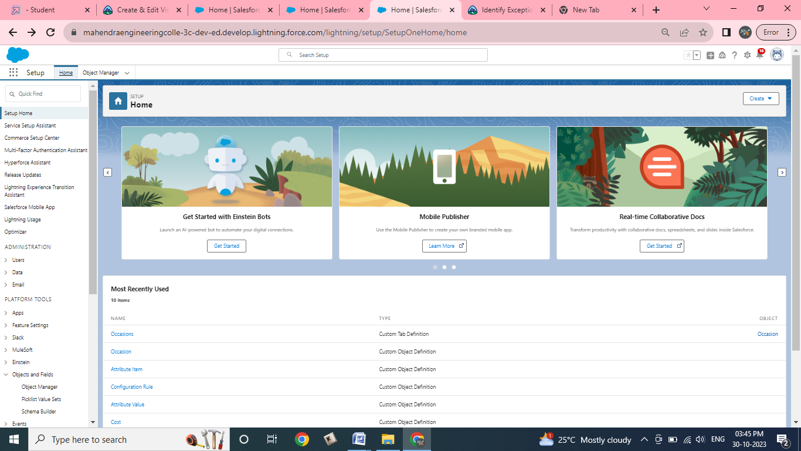

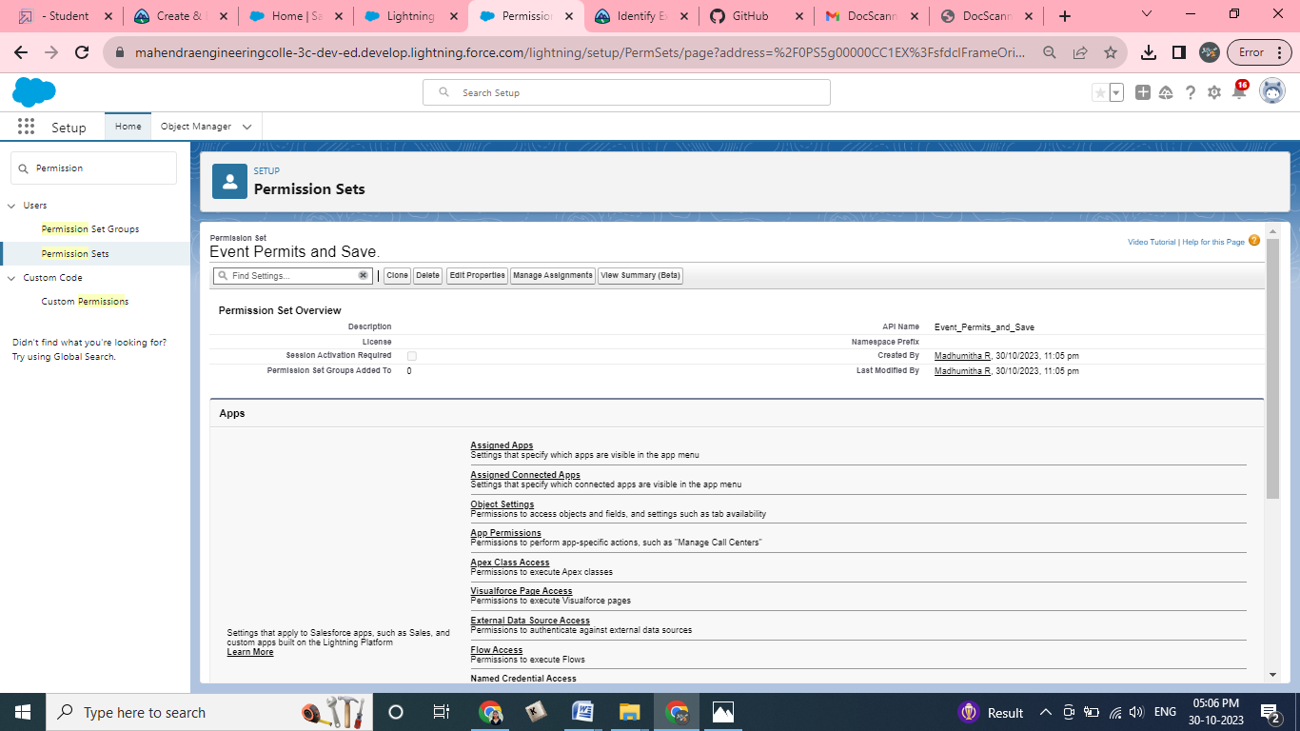

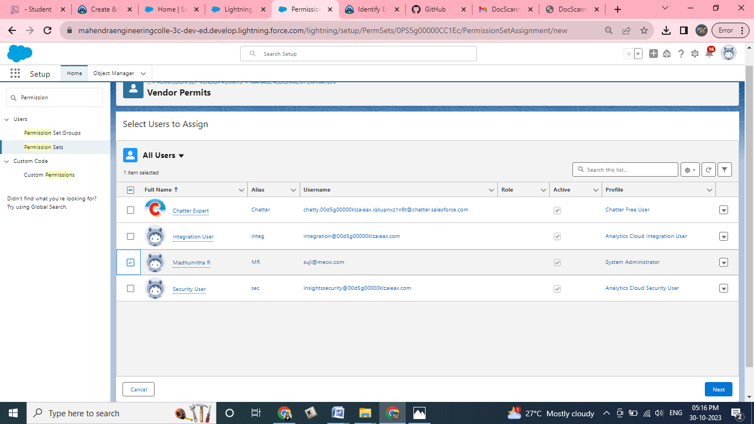

1. After saving the permission click on the Manage assignment
2. Now click on the Add Assignment
3. Now select the users and click on next Assign ,Done

